Who is Tour Partner Group?
Tour Partner Group is a leading B2B destination management company for the Nordics, the United Kingdom, and Ireland. Tour Partner Group brings together more than 250 destination specialists, designing B2B travel for groups, FIT and the MICE industry with offices in Copenhagen, London, Edinburgh, and Dublin. We are the experts in developing European tours for the travel business, and in creating authentic experiences and memories that last a lifetime. Our mission is to deliver personally tailored, authentic tours. Perfectly.
At our Copenhagen office, we are currently looking for a Department Manager for our French Team.

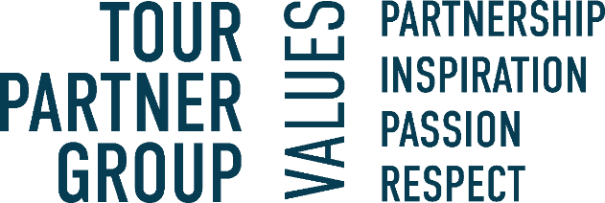

About the position:

Initially, the Department Manager will focus on team leadership responsibilities, gradually transitioning into broader managerial duties. Key responsibilities include:

Leading and managing a team, fostering a positive and productive working environment.

Providing guidance, motivation, and support to team members, ensuring their growth and development.

Coordinating daily operations, ensuring efficiency and alignment with client expectations.

Conducting performance evaluations, setting goals, and providing feedback to team members.

Managing client relationships, ensuring their needs are understood and met through team efforts.

Collaborating with stakeholders internally and externally to align strategies and goals.

Identifying training needs and facilitating skill development within the team.

Handling team emergency escalations and addressing urgent issues.

Participating in departmental and management meetings, contributing to strategic planning and decision-making.
- Efficiently manage entire employee life-cycle (hiring, coordinate employee holidays, manage absence, conduct PU talk etc.)
- Monitor and set plans to secure team goals and KPIs are met.
- Be actively involved in making department budget.

We are looking for the following skills & experience:
- Minimum of 6 years of experience in the Tour Operation Business, with exposure to multiple roles and a track record of leadership.
- Proven leadership experience with responsibilities for team management, operations control, client management, and financial results.
- Excellent French communication and interpersonal abilities, with proficiency in English
- Strong familiarity with the Scandinavian market and travel industry dynamics.
- Bachelor's degree in business administration or a related field is a plus.
- Financial literacy and proficiency in budgeting and financial management.
- Experience in providing feedback, mentoring, and guiding team members towards success.
- Ability to handle pressure, maintain composure, and remain positive in challenging situations.
- Capable of comprehending and effectively implementing company policies.
- Strong organizational skills, attention to detail, communication abilities, problem-solving capabilities, time management, and respect for confidentiality.

Interested in the position? In our team we value those personal traits:
- Demonstrates a strong work ethic and leadership skills that empower others with an inspiring personality.
- Takes ownership of responsibilities while remaining empathetic and resilient under pressure
- Exhibits loyalty, reliability, flexibility, enthusiasm, and proactiveness.
- Possesses attention to detail, accuracy, and consistency in all tasks.
- Ability to have bigger picture in mind even when heavily involved in daily tasks.
- Excellent communication, conflict resolution and problem-solving skills.
- Strong financial acumen as well as organizational and excel skills.
- You are friendly, positive, and most importantly service-minded team-member.

What will you get from working at Tour Partner Group?
- A position with responsibility and visibility.
- Training and development on the job. We commit to helping you to be your best.
- A positive and energetic team which helps one another.
- An international environment: our multinational team (> 20 nationalities) work with international clients.
- Bright and creative office located 10 minutes walking from Ryparken station and 15 minutes walking from Hellerup station. Bus lines are available, with only a few minutes’ walking from the bus to the office.
- Lunch scheme – canteen catered by Comwell Hotels.
- According to skills and attitude - possibilities to develop to other exiting positions within the company.
- Salary - according to qualifications, including pension and health insurance.
- Bonus based on performance.
If you have any questions regarding the positions, you are welcome to contact our Office Manager & HR- Mette Nielsen: 4597 0711
If you're ready to take on an exciting role in a dynamic environment, where your technical expertise and problem-solving skills will be valued, apply now via the link.

