Who is Tour Partner Group?
Tour Partner Group is a leading B2B destination management company for the Nordics, the United Kingdom, and Ireland. Tour Partner Group brings together more than 250 destination specialists, designing B2B travel for groups, FIT and the MICE industry with offices in Copenhagen, London, Edinburgh, and Dublin. We are the experts in developing European tours for the travel business, and in creating authentic experiences and memories that last a lifetime. Our mission is to deliver personally tailored, authentic tours. Perfectly.

At our Copenhagen office, we are currently looking for two Operations Coordinators:
- 1 German speaking for our DACH Market
- 1 Mandarin speaking for our Southeast Asian Market

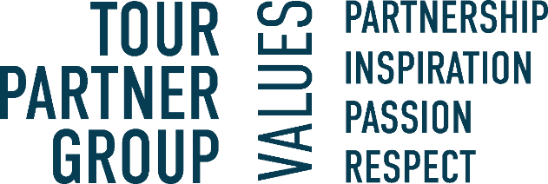

About the position:

You will be the first point of contact for our clients and will have responsibility for their performance and satisfaction. Together with your clients you will develop authentic itineraries and create memories for their customers that will last a lifetime. You will be part of a team of passionate colleagues from all over the world, who stand together and help each other across departments.

- Support senior team members in crafting engaging tour itineraries and packages.
- Coordinating logistics and booking accommodations, transport, and activities etc.
- To be in contact with the Tour Leader during the tour on a regular basis to make further adjustments in the program if needed and solve any problems.
- To double check, get the final travel documents ready and send them to the client.
- Monitor if payment conditions are respected, and/or that invoices are accurate and on time. Will report eventual delays to the DM/supervisor or team leader.
- Provide support and/or cover for other departments when needed.

We are looking for the following skills & experience:

- For the position in the DACH Department, we expect that you are fluent in German both written and spoken.
- For the position in the Far East Department, we expect that you are fluent in Mandarin both written and spoken.
- Both positions require a high level of written and spoken English.
- Passion for the travel and tourism industry. Experience within the travel industry is a plus.
- Strong organizational skills and attention to detail.
- Excellent communication and interpersonal abilities.
- Relevant education or coursework is a plus.
- Good computer skills and fluency with Microsoft office package
- Ability to work effectively in a fast-moving organization and dynamic environment.

Interested in the position? In our team we value those personal traits:
- Commitment to deliver results.
- Willingness to assume more responsibility and grow in your role.
- You are friendly, positive, and most importantly service-minded team-member.

What will you get from working at Tour Partner Group?
- A position with responsibility and visibility.
- Training and development on the job. We commit to helping you to be your best.
- A positive and energetic team which helps one another.
- An international environment: our multinational team (> 20 nationalities) work with international clients.
- Bright and creative office located 10 minutes walking from Ryparken station and 15 minutes walking from Hellerup station. Bus lines are available, with only a few minutes’ walking from the bus to the office.
- Lunch scheme – at canteen catered by Comwell Hotels.
- According to skills and attitude - possibilities to develop to other exiting positions within the company.
- Salary - according to qualifications, including pension and health insurance.
- Bonus scheme based on performance.
You should be prepared that there will be overtime, especially during our high seasons. Overtime is compensated for.
If you have any questions regarding the positions, you are welcome to contact our Office Manager & HR- Mette Nielsen: 4597 0711
If you're ready to take on an exciting role in a dynamic environment, where your technical expertise and problem-solving skills will be valued, apply via the link.

