Who is Tour Partner Group?
Tour Partner Group is a leading B2B destination management company for the Nordics, the United Kingdom, and Ireland. Tour Partner Group brings together more than 250 destination specialists, designing B2B travel for groups, FIT and the MICE industry with offices in Copenhagen, London, Edinburgh, and Dublin. We are the experts in developing European tours for the travel business, and in creating authentic experiences and memories that last a lifetime. Our mission is to deliver personally tailored, authentic tours. Perfectly.

At our Copenhagen office, we are currently looking for a Contracting Manager.

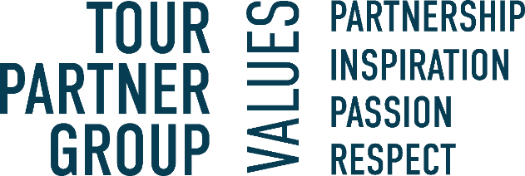

About the position:

Join our dynamic Contracting team at Tour Partner Group in Copenhagen. As a Contracting Manager, you'll negotiate contracts, maintain strong supplier relationships, and ensure reliable service and favorable terms. Your ability to communicate effectively with diverse stakeholders, including suppliers and internal teams, will be essential in managing contracts and negotiating prices to benefit our company. You'll also provide data-driven insights to support team decisions and keep our booking system up-to-date, contributing to seamless, unforgettable travel experiences tailored to our clients' needs.
Key responsibilities include:

- Contract Review: Evaluate and negotiate contracts, using data insights to secure great rates and terms.

- Supplier Relationships: Build and maintain strong connections with suppliers, handling any issues with diplomacy and strategic thinking.

- Negotiation: Leverage market knowledge to get competitive rates and ensure we have the best options available.

- Communication & Problem-Solving: Clearly share our needs with suppliers, quickly resolving any issues to keep things on track.

- Reporting: Create reports that highlight trends and pricing to help guide our decisions.

- Process Improvement & Inventory: Work on projects to streamline processes, ensure data accuracy, and manage inventory in our booking system for smooth operations

We are looking for the following skills & experience:
- Relevant Experience: Background in roles such as Operations Executive, Sales Executive, Contracting Manager, booking agent, or similar.
- Data Proficiency: Advanced skills in Microsoft Excel or Power BI; knowledge of additional data analysis tools is a plus.
- Analytical & Negotiation Skills: Strong numerical and analytical abilities with experience using data insights for strategic supplier negotiations.
- Attention to Detail & Strategic Approach: Exceptional attention to detail and a strategic approach to ensure data accuracy, reliability, and effective decision-making.
- Communication & Industry Knowledge: High proficiency in English and a Nordic language, with a solid understanding of the travel industry market and culture

Interested in the position? In our team we value those personal traits:
- Structured, good at planning and able to meet deadlines.
- Revenue focused and driven to achieve targets.
- Good negotiation skills.
- Commitment to deliver results.
- Willingness to assume more responsibility and grow in your role.
- You are friendly, positive, a good team player and most importantly service-minded.

What will you get from working at Tour Partner Group?
- A position with responsibility and visibility.
- Training and development on the job. We commit to helping you to be your best.
- Be part of a company with offices in various locations in Europe and opportunity to grow within the group
- A positive and energetic team which helps one another.
- An international environment: our multinational team (> 20 nationalities) work with international clients.
- Bright and creative office located 10 minutes walking from Ryparken station and 15 minutes walking from Hellerup station. Bus lines are available, with only a few minutes’ walking from the bus to the office.
- Lunch scheme – canteen catered by Comwell Hotels.
- According to skills and attitude - possibilities to develop to other existing positions within the company.
- Salary - according to qualifications, including pension and health insurance.
- Bonus scheme based on performance.
If you have any questions regarding the positions, you are welcome to contact our Office Manager & HR- Mette Nielsen: 4597 0711
If you're ready to take on an exciting role in a dynamic environment, where your technical expertise and problem-solving skills will be valued, apply now. Apply by clicking the button 'Apply online'.

