Who is Tour Partner Group?
Tour Partner Group is a leading B2B destination management company for the Nordics, the United Kingdom, and Ireland. Tour Partner Group brings together more than 250 destination specialists, designing B2B travel for groups, FIT and the MICE industry with offices in Copenhagen, London, Edinburgh, and Dublin. We are the experts in developing European tours for the travel business, and in creating authentic experiences and memories that last a lifetime. Our mission is to deliver personally tailored, authentic tours. Perfectly.

At our Copenhagen office, we are currently looking for a LDC and Contracting Manager.

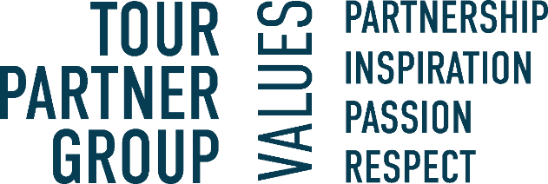

About the position:

We specialize in delivering personally tailored, authentic tours across Scandinavia. As a part of our Contracting team, you'll play a key role in ensuring smooth operations of our Long Distance Coaches (LDC) for our tours around the Nordic Destinations. You'll have direct contact with our LDC suppliers, handling LDC logistics, managing contracts and negotiating prices to benefit our company. In this role, you will also deliver crucial service to our sales and operation team. Our booking system is the company's backbone, and you will help keep it updated with the latest data.

Key responsibilities include:

- LDC Logistics & Emergency Handling: Plan, coordinate, and ensure the smooth execution of tours across the Nordic region. Manage the emergency phone, resolving issues quickly to minimize disruptions.

- Contract Analysis & Negotiation: Obtain, review, and negotiate contracts, leveraging data-driven insights to secure optimal rates and terms in support of our growth objectives.

- Supplier Management: Build and maintain strong relationships with LDC suppliers to ensure reliable service and favourable terms.

- Reporting & Data Management: Create detailed internal reports on supplier usage, trends, and pricing, and participate in process optimization to ensure accurate data management.

- Inventory Management: Ensure the precise and timely loading of inventory (products and prices) into our system for seamless company-wide operations.

We are looking for the following skills & experience:
- Relevant Experience: Background in Operations Executive, Sales Executive, Contracting Manager, booking agent, or similar roles, with In-depth knowledge of our Nordic Destinations.

- Logistics & Coordination: Strong logistical skills, good coordination, and the ability to maintain an overview.
- Independence & Multitasking: Ability to work independently and handle multiple tasks efficiently.
- Analytical Skills: High numerical and analytical skills with a knack for problem-solving.
- Conflict Resolution: Proven skills in resolving conflicts and addressing issues strategically.
- Communication: Proficient in English, with knowledge of a Nordic language.

Interested in the position? In our team we value those personal traits:
- Structured, good at planning and able to meet deadlines.
- Revenue focused and driven to achieve targets.
- Good negotiation skills.
- Commitment to deliver results.
- Willingness to assume more responsibility and grow in your role.
- You are friendly, positive, a good team player and most importantly service-minded.

What will you get from working at Tour Partner Group?
- A position with responsibility and visibility.
- Training and development on the job. We commit to helping you to be your best.
- Be part of a company with offices in various locations in Europe and opportunity to grow within the group.
- A positive and energetic team which helps one another.
- An international environment: our multinational team (> 20 nationalities) work with international clients.
- Bright and creative office located 10 minutes walking from Ryparken station and 15 minutes walking from Hellerup station. Bus lines are available, with only a few minutes’ walking from the bus to the office.
- Lunch scheme – canteen catered by Comwell Hotels.
- According to skills and attitude - possibilities to develop to other existing positions within the company.
- Salary - according to qualifications, including pension and health insurance.
- Bonus scheme based on performance.
If you have any questions regarding the positions, you are welcome to contact our Office Manager & HR- Mette Nielsen: 4597 0711
If you're ready to take on an exciting role in a dynamic environment, where your technical expertise and problem-solving skills will be valued, apply now. Apply by clicking the button 'Apply online'.

