Who is Tour Partner Group?
Tour Partner Group is a leading B2B destination management company for the Nordics, the United Kingdom, and Ireland. Tour Partner Group brings together more than 250 destination specialists, designing B2B travel for groups, FIT and the MICE industry with offices in Copenhagen, London, Edinburgh, and Dublin. We are the experts in developing European tours for the travel business, and in creating authentic experiences and memories that last a lifetime. Our mission is to deliver personally tailored, authentic tours. Perfectly.

At our Copenhagen office, we are currently looking for 2 new employees to our FIT Team in the Nordics (on site in Copenhagen).

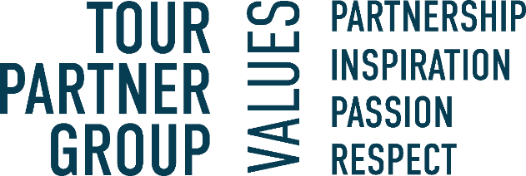

About the position:

As FIT Sales & Operations Executive primarily handle day-to-day operational tasks providing essential support for sales activities. This role entails managing operational functions and supporting sales efforts. This role provides an opportunity to manage FIT tours end-to-end, ensuring a high level of quality and financial success for each itinerary.

- Prepare costing and quotations for FITs within an agreed time frame and in the required presentation style, aiming to maximize margins on all quotations.
- Ensure a high materialization rate by effectively converting quotations into confirmed bookings.
- Coordinate and book accommodations, transport, and activities for FITs, ensuring all logistics are efficiently managed.
- Negotiate with suppliers to secure the best products at the best possible prices, ensuring high-quality options for clients.
- Ensure that the conditions of payment are respected and manage the financial aspects of FIT tours to maintain profitability.
- Assist with other tasks in the FIT department and other departments during off-peak seasons and participate in FAM trips for staff and agents.
- Handle emergency phone duties.

We are looking for the following skills & experience:

- For the position, we expect that you speak Fluent French or English both written and spoken.
- Good knowledge of the Scandinavian market with relevant experience from a Scandinavian incoming agency or similar.
- Experience in sales, showcasing a track record of successful sales initiatives and client purchase.
- Familiarity with sales support activities, client engagement, and lead follow-ups.
- Effective communication and collaboration abilities for cross-functional coordination.
- Strong organizational skills and attention to detail.
- Relevant education or coursework is a plus.
- Good computer skills and fluency with Microsoft office package
- Service-minded.

Interested in the position? In our team we value those personal traits:
- You have a strong financial understanding and are driven by success criteria such as growth and guest satisfaction.
- Able to keep deadlines.
- Structured and good at planning
- Revenue focused and driven to achieve targets.
- Good negotiation skills.
- Commitment to deliver results.
- Willingness to assume more responsibility and grow in your role.
- You are friendly, positive, a good team player and most importantly service-minded.

What will you get from working at Tour Partner Group?
- A position with responsibility and visibility.
- Training and development on the job. We commit to helping you to be your best.
- A positive and energetic team which helps one another.
- An international environment: our multinational team (> 20 nationalities) work with international clients.
- Bright and creative office located 10 minutes walking from Ryparken station and 15 minutes walking from Hellerup station. Bus lines are available, with only a few minutes’ walking from the bus to the office.
- Lunch scheme – canteen catered by Comwell Hotels.
- According to skills and attitude - possibilities to develop to other existing positions within the company.
- Salary - according to qualifications, including pension and health insurance.
- Bonus scheme based on performance.

You should be prepared that there will be overtime, especially during our high seasons. Overtime is compensated for.
Presentation of a valid work and residence permit is required to sign a contract.
If you have any questions regarding the positions, you are welcome to contact our Office Manager & HR- Mette Nielsen: 4597 0711
If you're ready to take on an exciting role in a dynamic environment, where your technical expertise and problem-solving skills will be valued, apply via the link.

