Who is Tour Partner Group?
Tour Partner Group is a leading B2B destination management company for the Nordics, the United Kingdom, and Ireland. Tour Partner Group brings together more than 250 destination specialists, designing B2B travel for groups, FIT and the MICE industry with offices in Copenhagen, London, Edinburgh, and Dublin. We are the experts in developing European tours for the travel business, and in creating authentic experiences and memories that last a lifetime. Our mission is to deliver personally tailored, authentic tours. Perfectly.
At our Copenhagen office, we are currently looking for a Senior Sales and Operations Executive for our French Market (on site in Copenhagen).

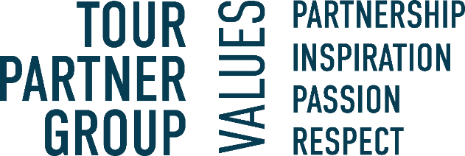

About the position:

The Senior Sales & Operations Executive primarily handles day-to-day operational tasks providing essential support for sales activities. This role entails managing operational functions and supporting sales efforts. The responsibilities involve handling client interactions, following up on leads, making quotations and occasionally participating in client visits or events.

Following up on leads and be in direct contact with clients conducting negotiations/amendments

Making quotations and secure a high materialization rate

Coordinating logistics and booking accommodations, transport, and activities.

To be in contact with the Tour Leader during the tour on a regular basis to make further adjustments in the program if needed and solve all problems.

Ownership of tours and accountability for its quality and financial results

Making sure that the conditions of payment are respected.

Negotiation with suppliers are important aspects of the job to be able to offer the customer the best product at the best possible price.

Provide support and/or cover for other departments when needed.

Emergency phone

Occasional involvement in sales-related activities and client engagements.
We are looking for the following skills & experience:
- For the position in the French Department, we expect that you are fluent in French both written and spoken.
- Good knowledge of the Scandinavian market with relevant experience from a Scandinavian incoming agency or similar.
- Experience in sales, showcasing a track record of successful sales initiatives and client purchase.
- Familiarity with sales support activities, client engagement, and lead follow-ups.
- Effective communication and collaboration abilities for cross-functional coordination.
- Strong organizational skills and attention to detail.
- You have a high level of written and spoken English.
- Relevant education or coursework is a plus.
- Good computer skills and fluency with Microsoft office package
- Service-minded.

Interested in the position? In our team we value those personal traits:
- You have a strong financial understanding and are driven by success criteria such as growth and guest satisfaction.
- Able to keep deadlines.
- Structured and good at planning
- Revenue focused and driven to achieve targets.
- Good negotiation skills.
- Commitment to deliver results.
- Willingness to assume more responsibility and grow in your role.
- You are friendly, positive, a good team player and most importantly service minded.

What will you get from working at Tour Partner Group?
- A position with responsibility and visibility.
- Training and development on the job. We commit to helping you to be your best.
- A positive and energetic team which helps one another.
- An international environment: our multinational team (>20 nationalities) works with international clients.
- Bright and creative office located 10 minutes walking from Ryparken station and 15 minutes walking from Hellerup station. Bus lines are available, with only a few minutes’ walking from the bus to the office.
- Lunch scheme – canteen catered by Comwell Hotels.
- According to skills and attitude - possibilities to develop to other existing positions within the company.
- Salary - according to qualifications, including pension and health insurance.
- Bonus scheme based on performance.

You should be prepared that there will be overtime, especially during our high seasons. Overtime is compensated for.
Presentation of a valid work and residence permit is required to sign a contract.
If you have any questions regarding the positions, you are welcome to contact our Office Manager & HR- Mette Nielsen: 4597 0711
If you're ready to take on an exciting role in a dynamic environment, where your technical expertise and problem-solving skills will be valued, apply via the link.

