Who is Tour Partner Group?
Tour Partner Group is a leading B2B destination management company for the Nordics, the United Kingdom, and Ireland. Tour Partner Group brings together more than 250 destination specialists, designing B2B travel for groups, FIT and the MICE industry with offices in Copenhagen, London, Edinburgh, and Dublin. We are the experts in developing European tours for the travel business, and in creating authentic experiences and memories that last a lifetime. Our mission is to deliver personally tailored, authentic tours. Perfectly.
At our Copenhagen office, we are currently looking for a Team Leader for our Far East Team.

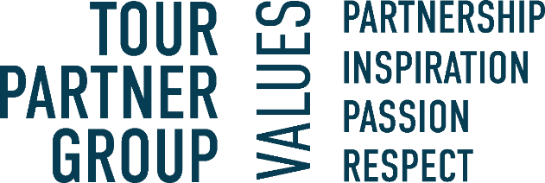

About the position:

As Team Leader, you will oversee daily operations, guide a small team, and ensure alignment with client expectations and company goals. This role combines operational management, client relationship handling, and team development to create a positive and productive working environment. Key responsibilities include:

- Lead and manage a small team, fostering a collaborative and efficient work culture.
- Coordinate daily operations, adjust workflows, and assign tasks to meet deadlines and goals.
- Handle administrative duties such as creating overviews, reports, monitoring holidays, sickness, and emergency phone escalations.
- Own the entire employee life-cycle in the company, including recruiting, onboarding, conduct performance evaluations, set and monitor goals, and provide constructive feedback to team members, offboard when necessary.
- Ensure quality in operations, including quotation checks and pre/post-season analyses.
- Collaborate with other teams and align sales and operations with client expectations.
- Identify training needs and facilitate team development opportunities.
- Act as a liaison between upper management and the team, conveying information and goals effectively.
- Manage client relationships, ensuring needs are met through coordinated team efforts.
We are looking for the following skills & experience:
- A proven track record in a leadership or supervisory role, from the travel or tourism industry. Preferably from the incoming industry.
- Solid knowledge of the Scandinavian market and products, ideally from a Scandinavian incoming agency or similar.
- Strong skills in task delegation, workload balancing, and conflict resolution.
- Financial literacy and experience in managing budgets or KPIs.
- Excellent communication skills, both written and verbal, in English, Mandarin is a plus.
- Empathy and resilience to support team members under pressure.
- A proactive mindset, with strong problem-solving abilities and a focus on continuous improvement.
- Familiarity with relevant tools and platforms, including TimeMap, PowerBI and Hi Bob, is a plus.

Interested in the position? In our team we value those personal traits:
- Demonstrates a strong work ethic and leadership skills that empower others with an inspiring personality.
- Takes ownership of responsibilities while remaining empathetic and resilient under pressure
- Exhibits loyalty, reliability, flexibility, enthusiasm, and proactiveness.
- Possesses attention to detail, accuracy, and consistency in all tasks.
- The ability to have the bigger picture in mind even when heavily involved in daily tasks.
- Excellent communication, conflict resolution and problem-solving skills.
- Strong financial acumen as well as organizational and excel skills.
- You are friendly, positive, and most importantly service-minded team-member.

What will you get from working at Tour Partner Group?
- A position with responsibility and visibility.
- Training and development on the job. We commit to helping you to be your best.
- A positive and energetic team which helps one another.
- An international environment: our multinational team (> 20 nationalities) work with international clients.
- Bright and creative office located 10 minutes walking from Ryparken station and 15 minutes walking from Hellerup station. Bus lines are available, with only a few minutes’ walking from the bus to the office.
- Lunch scheme – canteen catered by Comwell Hotels.
- According to skills and attitude - possibilities to develop to other exiting positions within the company.
- Salary - according to qualifications, including pension and health insurance.
- Bonus based on performance.
If you have any questions regarding the positions, you are welcome to contact our Office Manager & HR- Mette Nielsen: 4597 0711
If you're ready to take on an exciting role in a dynamic environment, where your technical expertise and problem-solving skills will be valued, apply now via the link.

